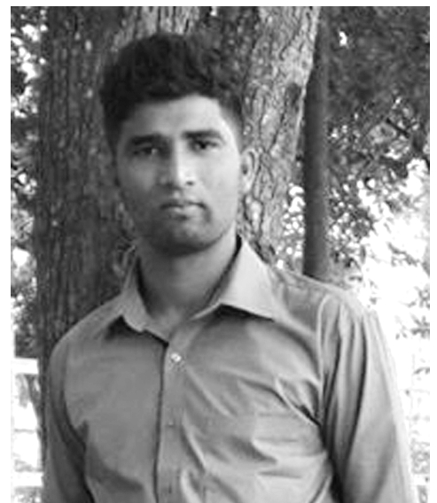
Mr.T.Pratheepan,
Kottawaththai,
Kadaipuliyadi,
Alvai west,
Point petro,
Jaffna.
0094771862553
pratheepan1612@gmail.com

Career Objectives

“To acquire knowledge and experience in Engineering, management activities and ultimately reaching the highest possible position in the organization while providing the organization with the best’’

Personal Profile

I am a self-motivated and flexible individual .I willing to meet demanding challenges. I enjoy working as a team member and I am comfortable in communicating with people at all levels. I am sure that I will adapt to any type of working environment and be a valuable member of the working team.”

Education

- Successfully completed Bachelor of Art (BA), University of Jaffna.
- Successfully completed Diploma in Software.
- Successfully completed Diploma in Hardware.

Personal Details
Name in full : Mr.Thayaparan Pratheepan
Nationality : Sri Lankan
National I.D. Number : 893512616V
Driving License No : B1995891
Date of Birth : 16.12.1989
Sex : Male
Civil Status : Single
Schools Attended : J/Thejarayali hindu college.

Educational Qualification
Higher Education

Bachelor of Arts General Degree,

University of Jaffna, Sri lanka at Jaffna.


Specialization stream: Political science & Linguistics

Medium: Tamil
Duration: Three Years (Full Time)

College education

- G.C.E. (O/L) – December 2006 ( A,2B,4C,S)
- G.C.E. (A/L) – August 2010 ( A , 2B )

Extra-Curricular Activities

Languages

Fluently speaking and Writing in Tamil, Working knowledge in English.
- Represented University of Jaffna Football team
- Endowed with the University of Jaffna colors insignia as his alma mater’s tribute to his loyalty and performance.
- Annual Inter faculty fresher’s track & field championship
- Inter university track & field championship
- Represented sivanantha sports club
- Member of Solid sports club
- School Athletic caption
- School prefect

Referees

Prof.N.Gnakumaran Mr.M.Elampraiyan
Dean, Senior Lecturer,
Faculty of arts, Physical Education,
University of Jaffna. University of Jaffna.
+9477 6447001 +9477 3405978

I do here by certify that the above particulars are true and accurate to the best of my knowledge.

......................... ............................
(T.Pratheepan) (Date)

